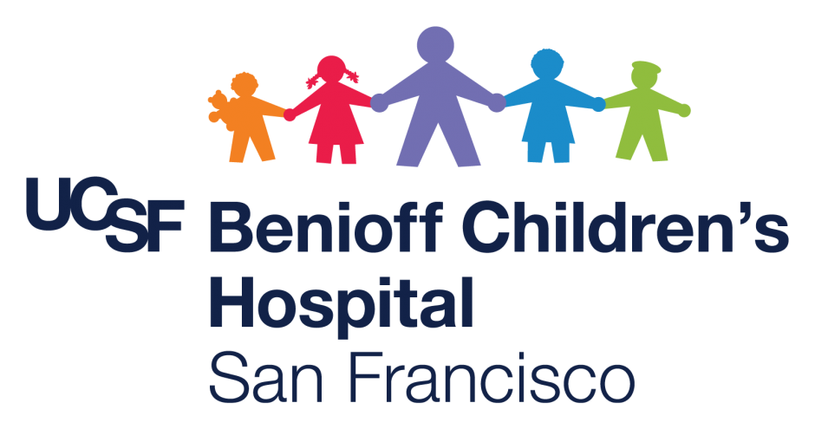

Date: October 2022

To: Family of Kashia

Your provider has asked for your child’s After Visit Summary (discharge paper work) to be translated from English to Punjabi. Apologies, that you are receiving this after some time retuning home.

If you have any questions, you may contact me at (415) 476-8310.

Thank you and take care.

Sincerely
Gabriela

Gabriela Quezada-Perez
Clinical Care Coordinator
UCSF Benioff Children’s Hospitals

C5 Medical-Surgical & Transitional Care Units
1975 4th Street | San Francisco, CA 94158
Voalt Phone: 415.476.8310
gabriela.quezada-perez@ucsf.edu

